Role Profile

Job Description

Job Title | Children & Young People’s Domestic Violence Practitioner - Female*
Salary | £26,451 (pro rata) £21,577.92 (Actual salary)
Responsible to | Children & Young People’s Team Leader & Operations Manager (Refuge)
Hours | 28 hours per week
Contract | Permanent

This post will be subject to an enhanced DBS check and there is an Occupational Requirement under the Equality Act 2010 Schedule 9 (Part 1) for the post holder to be a woman.

Leeds Women’s Aid (LWA) is the largest women’s charity in Leeds, and has been providing support to women and children affected by Domestic Violence and Abuse (DV & A) for over 45 years. We are committed to our values and strive to embody them in everything we do. We provide a range of the very best services for vulnerable women and families who are victims and survivors of domestic, sexual & honour-based violence and abuse, forced marriage, trafficking, stalking and harassment.

LWA is the lead agency for Leeds Domestic Violence Service (LDVS), a consortium of 3 agencies offering support to women, men and transgender/non-binary people. This service works within a multi-agency framework and provides high quality, pro-active service to victims of domestic, sexual and honour-based violence and abuse, stalking and forced marriage, often those at the highest risk.

LWA is a member of the unique Women & Girls Alliance – Leeds, consisting of 11 women’s and girls’ organisations. Working with vulnerable women and girls, our vision is that many more women and girls in Leeds will have their needs met and be empowered to lead safer and healthier lives.

Purpose of Job
ELEVATE is a Children and Young People’s (CYP) Community Service working alongside Leeds schools, delivered by our two specialist CYP Domestic Violence Practitioners. The service provides intervention, specialist advocacy, emotional and practical support to children and young people who are experiencing and recovering from domestic violence and abuse or sexual violence at all levels of risk.

This postholder will provide a programme of support by delivering interventions with children and young people, within a school setting. Support and interventions may include assessing developmental, educational and trauma needs, safeguarding, advocating for CYP and therapeutic work. The postholder will ensure that each child’s needs are met by working collaboratively with parents, schools and partner agencies such as police, social workers, medical providers, legal professionals to achieve the best possible outcomes.

Leeds Women’s Aid provide safe, emergency refuge accommodation for individuals and families who are fleeing domestic violence and abuse. The ELEVATE team work closely with the wider refuge teams; working as part of a co-ordinated community response, applying specialist knowledge and skills in a variety of contexts to provide advocacy and support to ensure safety, wellbeing and recovery. You will carry out risk and needs assessments and undertake safety planning with victim-survivors and work within a multi-agency framework to ensure the safety of CYP, is prioritised.

Physical Conditions

The post will be based in our main refuge located within Leeds. You will also travel to other sites, including schools to offer services to CYP within the community.

The postholder will be required to hold a full driving licence and have access to a vehicle with business insurance.

Economic Conditions

This is a 28 hour per week post with an actual salary of £21,577

Responsibilities

Responsible to: Children and Young People’s Team Leader
All paid members of staff are accountable to the Chief Executive, and ultimately the Trustees of Leeds Women’s Aid, and will work according to policies and procedures agreed by them.

And close liaison with: Leeds Women’s Aid (LWA) and Leeds Domestic Violence Service (LDVS) Refuge services.

Main Duties

- Explore the emotional and practical needs of Children and Young People (CYP), to support and help them to respond to risk and/or recover.
- Build trusting professional relationships with CYP victim-survivors of domestic violence and abuse, providing specialist support via key working sessions, completing person-centred support plans, carry out risk assessments, safeguarding and safety planning.
- Develop a thorough understanding of a child’s life and history to provide effective needs-led support.
- Engage with CYP victim-survivors from marginalised and disadvantaged groups and diverse social backgrounds in ways that respond to their individual identities.
- Support is appropriate to age, developmental stage, cultural background and SEND needs. Support and safety planning will be needs-led, tailored to the individual with a Children’s Rights-based approach, culturally sensitive, responsive and inclusive ensuring CYP voices are heard and validated.
- Refer and signpost CYP to other relevant voluntary or statutory multi-agency partners. Establish and maintain effective collaborative working relationships with key agencies e.g. education providers, social care, health providers, courts etc, so that the needs of CYP, are met appropriately.
- Act as an independent advocate for CYP.
- Where safe to do so, work with the protective parents of CYP, with the support of schools or social care. Signposting to other parts of LDVS services or external agencies where applicable, to assist with parenting and family support.
- Where required, support CYP victim-survivors through police investigations and/or court processes within the context of own role.
- Completion of Young People’s DASH Risk Checklist and involvement in MARAC and/or DRAM.
- Be adaptable, using CYP age-specific activities, games and tools in a therapeutic space to help explore difficult topics and help CYP process emotions.
- Safeguarding is prioritised in a timely response and adhered to in accordance with LWA’s Safeguarding policies and Leeds local safeguarding protocols.
- Lone working: work with CYP within the community on an individual basis.
- To work with other LWA and LDVS colleagues where appropriate, to provide holistic interventions of care for families fleeing domestic violence and abuse, or sexual violence.
- To have a Trauma informed practice and approach.
- Reflect on own practice and access available supervision and case management support provided.
- Maintain own continuous professional development and revise practise based on feedback received.

General

- Attend staff meetings and other training events as required.
- To uphold LWA's policies, with particular reference to confidentiality, health and safety and equity, diversity and inclusion.
- Assist and promote the empowerment of survivors of domestic violence and abuse or sexual violence who may have experienced inequality, discrimination and/or forms of injustice.
- To carry out any other duties or training commensurate with the post.
- To carry out any other duties that are reasonably required by LWA

Person Specification

Our ideal candidate will be able to demonstrate

Experience | How Assessed:  A = Application Letter  I = Interview
- Experience of supporting Children and Young People, specifically experiencing or recovering from trauma. | AI
- Knowledge and experience of Safeguarding i.e. understanding of legislation and local Leeds protocols. | AI
- Knowledge of domestic violence and abuse, sexual violence, honour-based violence, stalking, coercive control etc. | AI
- Knowledge of the impacts of DV&A on victim-survivors. | AI
- Experience of working with families from diverse backgrounds. | AI
- Experience of working within a multi-agency framework and knowledge of Leeds based CYP services is desirable. | AI
- Experience of managing a caseload, implementing support plans, safety plans, risk assessments and understanding the importance of case recording. | AI
- Knowledge of completing reports for Children’s Social Care Conferences, meetings or similar. | AI

Understanding
- Desirable experience of delivering group activities or CYP programmes. | AI
- Tailoring age-appropriate/child developmental support plans and activities – to individual comfort levels & interests. | I
- Knowledge of vulnerable CYP needs whilst understanding their emotions and behaviours | I
- Knowledge and understanding of the ‘whole family approach’. | I
- Knowledge of Child Development Stages | I

Skills
- Strong interpersonal communication skills | AI
- Strong Professional Curiosity and Professional Boundaries skills | I
- Advocacy for children and young people – support CYP to have a voice and make their own decisions | AI
- Staying present with an empathetic approach when CYP become dysregulated | AI
- Recognise crisis situations and respond within the required timescales in line with organisational policies | AI
- Time management and organisational skills working on own initiative | I
- Lone working | I
- Effectively working with a multi-agency approach to ensure the best outcomes for the CYP or family is met. | AI
- Confident in managing a high case load & understanding the importance of case recording: we use a range of technology and systems | I

Professional Qualification
- Hold a Children and/or Young People’s qualification e.g. Social Care Degree, NVQ L3, NNEB or equivalent. | A
- Have significant and relevant experience of working with CYP. | AI
- Desirable: Trauma Informed Practice and/or Compassionate Approaches. | AI
- Hold a full driving licence and have access to a car. | A
Personal Qualities & Competencies
- Values must be consistent with those of LWA. | AI
- Be caring and compassionate. | I
- Be non-discriminating, anti-oppressive and anti-racist. | AI
- Be survivor-centred. | AI
- Be reliable and committed. | I
- We work with people at risk with an expectation that we work in a way that protects from further harm. | AI
- Ability to maintain confidentiality. | AI

LWA’s Values

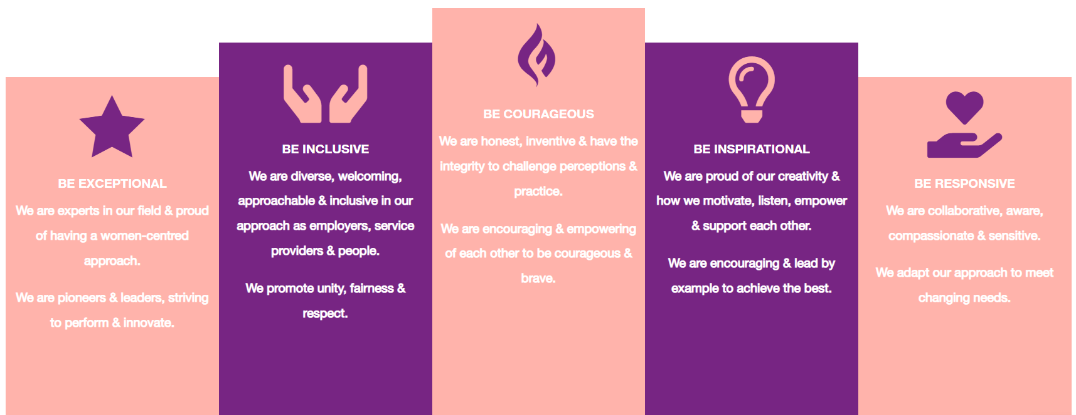

1. Be Exceptional
• We are experts in our field & proud of having a women-centred approach
• We are pioneers & leaders, striving to perform & innovate

2. Be Courageous
• We are honest, inventive & have the integrity to challenge perceptions & practice
• We are encouraging & empowering of each other to be courageous & brave

3. Be Inclusive
• We are diverse, welcoming, approachable & inclusive in as employers, service providers & people
• We promote unity, fairness & respect

4. Be Inspirational
• We are proud of our creativity & how we motivate, listen, empower & support each other
• We are encouraging & lead by example to achieve the best

5. Be Responsive
• We are collaborative, aware, compassionate & sensitive
• We adapt our approach to meet changing needs

