Role Description

Job Title | DV Support Worker (Relief) - female*
Pay | £12.60 per hour
Responsible to | Relief and Volunteer Coordinator
Hours | Various hours  Day / Weekends: 08:00 – 17:00  Evenings (including weekends): 16:30 – 22:30  Night shifts: 22:00 – 08:30
Contract | Relief hours to be worked on an as and when basis

This post will be subject to an enhanced DBS check and there is an Occupational Requirement under the Equality Act 2010 Schedule 9 (Part 1) for the post holder to be a woman.

Leeds Women’s Aid (LWA) is the largest women’s charity in Leeds, and has been providing support to women and children affected by Domestic Violence and Abuse (DV & A) for over 45 years. We are committed to our values and strive to embody them in everything we do. We provide a range of the very best services for vulnerable women and families who are victims and survivors of domestic, sexual & honour-based violence and abuse, forced marriage, trafficking, stalking and harassment.

LWA is the lead agency for Leeds Domestic Violence Service (LDVS), a consortium of 3 agencies offering support to women, men and transgender/non-binary people. This service works within a multi-agency framework and provides high quality, pro-active service to victims of domestic, sexual and honour-based violence and abuse, stalking and forced marriage, often those at the highest risk.

LWA is a member of the unique Women & Girls Alliance – Leeds, consisting of 11 women’s and girls’ organisations. Working with vulnerable women and girls, our vision is that many more women and girls in Leeds will have their needs met and be empowered to lead safer and healthier lives.

Purpose of Role
The DV Support Worker (Relief) supports women, children and families in our refuges across Leeds as well as provides telephone support and advice via our 24-hour helplines, both as part of our Access and Assessment Team (AAT) and within a refuge setting.

A variety of hours are available, depending on where you work.

After a period of training, shifts will be offered to you, but there is no obligation on you to accept the work. However, there is an expectation that you will complete a minimum of two shifts per month, a cover a minimum of one-night shift per month, with preferences considered. In addition to this, participate in ongoing professional development, including attendance at scheduled training sessions

Physical Conditions
Posts will be based across our refuge sites in Leeds and main office, and will include cover for a range of hours during the week from Monday to Sunday. The post holder may also have to travel to different locations to ensure effective service is provided to each client.

Economic Conditions
The pay will be £12.60 per hour. In addition, you will receive holiday pay, based on the number of hours worked.

Responsible To
DV Support Workers (Relief) are supported and managed by the Relief and Volunteer Coordinator but additionally, take direction from the Team Leader they are working for at the time.

All paid workers are accountable to the Chief Executive, and ultimate ly the Trustees of Leeds Women’s Aid, and will work according to policies and procedures agreed by them.

Main Duties

- To deliver high-quality trauma-informed support to victim-survivors including emotional support, risk assessment, safety planning and signposting
- To work with external organisations in processing and assessing referrals and providing advice and support when required
- To ensure case files and records are accurate and complete, and that both are kept in compliance with data protection legislation
- To provide a service which recognises the diverse needs of victim-survivors ensuring the service is accessible to all
- To provide support and guidance to other LWA staff to develop their skills, understanding and awareness of supporting victims-survivors who have experienced domestic abuse
- To assess people before coming in to the refuge, using LWA’s risk and needs assessment procedures
- To work closely with external agencies to meet the service users support needs where their needs are specialist e.g. substance use, self-harm, safeguarding, disability issues etc.
- To ensure all issues are communicated effectively within the team and write handover reports
- To provide ad hoc support to residents with benefits, issue licence/tenancy agreements and collect weekly charges and to work with clients in working towards a permanent housing solution
- To ensure physical standards are in order to ensure a welcoming environment with account taken of any health and safety issues
- To recognise safeguarding issues and to report to designated safeguarding lead as appropriate
- To ensure safeguarding standards are met and incidents are accurately logged and reported
- To deal effectively with any emergencies and ensure staff are informed in a timely manner
- To complete administrative duties, such as setting up service user files, filing, appropriate paperwork
- To develop a range of activities with residents at weekends and evenings
- To maintain confidentiality at all times

General

- To undertake training as required
- To ensure important matters are communicated effectively within the team
- To embrace anti-discriminatory practice in all aspects of this role
- To work at all times in a non-directive, non-judgmental and empowering way with all current service users and callers to the service
- To undertake any training or development opportunities provided by LWA
- To carry out any other duties that areas reasonably required by LWA
- To take all reasonable precautions to ensure your health and safety while at work, as well as that of your colleagues, clients and visitors to refuge, in accordance with LWA’s Health and Safety Policy
Person Specification for all roles
Our ideal candidate will be able to offer:

Experience | How Assessed:  A = Application Letter  I = Interview
- Working with other voluntary and statutory services involved in the response to domestic violence and abuse | A
- Accurately recording and reviewing detailed information | I
- Assessing the needs of vulnerable adults, children and young people | A&I
- Working in supported housing | A&I
- Identifying/reporting of Adult and Child protection issues | I
- Working on a helpline | A&I
Understanding

- An understanding of mental health, substance misuse and complex needs | I
- An understanding of risk and safety issues relating to domestic violence and women and children | I
- Child protection and safeguarding adults in relation to DV&A | I
- An understanding of the physical, social, and emotional impact of trauma/Domestic Abuse on individuals/victims/survivors and their children | A&I
- Clear understanding of equality issues and marginalisation of various groups and communities | I
- An understanding of the responsibilities of statutory agencies towards victim/survivors and children experiencing domestic violence. | A
- Sexual and honour-based violence and abuse, stalking and forced marriage - desirable | I
Skills
- Ability to form good relationships with service users whilst working within professional boundaries | I
- Ability to communicate effectively with a broad range of people. | A&I
- Ability to work under own initiative, identify objectives and prioritise work within a busy setting | I
- Excellent written, verbal and interpersonal communications skills | A&I
- Excellent crisis management skills and the ability to deal with stressful and difficult situations | I
- Good IT skills, including the ability to use databases and software and being able to present information clearly | A
- A calm confident telephone manner | I
Personal Qualities
- Values consistent with those of LWA | A&I
- A commitment to upholding LWA’s policies and procedures | I
- A commitment to diversity and working in an anti-discriminatory way | A&I
- The ability to work flexibly | A&I
- Act with integrity and respect when interacting with service users, employees, agencies and individuals | I
- Can work on your own initiative and manage a lone working environment | I

LWA’s Values
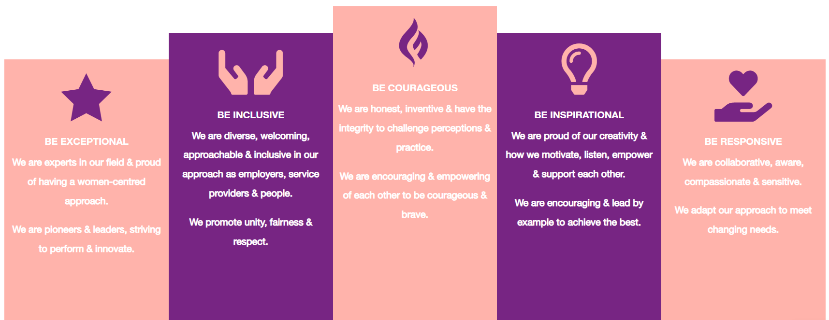

1. Be Exceptional
• We are experts in our field & proud of having a women-centred approach
• We are pioneers & leaders, striving to perform & innovate

2. Be Courageous
• We are honest, inventive & have the integrity to challenge perceptions & practice
• We are encouraging & empowering of each other to be courageous & brave

3. Be Inclusive
• We are diverse, welcoming, approachable & inclusive in as employers, service providers & people
• We promote unity, fairness & respect

4. Be Inspirational
• We are proud of our creativity & how we motivate, listen, empower & support each other
• We are encouraging & lead by example to achieve the best

5. Be Responsive
• We are collaborative, aware, compassionate & sensitive
• We adapt our approach to meet changing needs

