Role Profile

Job Description

Job Title | Out-of-Hours Evening & Weekend Worker Female*, Leeds
Salary | £22,986.60 (FTE 35 hours per week)
Responsible to | Out-of-Hours Team Leader
Hours | Saturday 8am – 4pm (7.5 hrs)  Saturday 3:30pm – 10:30pm (6.5 hrs)
Contract | Temporary

This post will be subject to an enhanced DBS check and there is an Occupational Requirement under the Equality Act 2010 Schedule 9 (Part 1) for the post holder to be a woman.

Leeds Women’s Aid (LWA) is the largest women’s charity in Leeds, and has been providing support to women and children affected by Domestic Violence and Abuse (DV & A) for over 45 years. We are committed to our values and strive to embody them in everything we do. We provide a range of the very best services for vulnerable women and families who are victims and survivors of domestic, sexual & honour-based violence and abuse, forced marriage, trafficking, stalking and harassment.

LWA is the lead agency for Leeds Domestic Violence Service (LDVS), a consortium of 3 agencies offering support to women, men and transgender/non-binary people. This service works within a multi-agency framework and provides high quality, pro-active service to victims of domestic, sexual and honour-based violence and abuse, stalking and forced marriage, often those at the highest risk.

LWA is a member of the unique Women & Girls Alliance – Leeds, consisting of 11 women’s and girls’ organisations. Working with vulnerable women and girls, our vision is that many more women and girls in Leeds will have their needs met and be empowered to lead safer and healthier lives.

Purpose of Job

The Evening and Weekend Worker provides specialist guidance and support to our residents living in our refuge accommodation and offers a 24-hour helpline service to victim-survivors. The helpline is the first point of contact for, and access to LDVS services for any person experiencing domestic violence and abuse. The role also contributes to the delivery of high-quality, trauma-informed and person-centred administrative and support services within our main LDVS refuge accommodation.

The successful candidate will be a vital role within our dedicated team, ensuring the effective operation of our refuge and helpline services. They will demonstrate a strong commitment to supporting victim-survivors of domestic violence and abuse, prioritising their safety, wellbeing and recovery.

Physical Conditions

The post will be based in our main LDVS refuge accommodation.

Occasional visits to dispersed properties or other LWA refuges within Leeds may be required in response to emergencies; however, all visits are supported by established safety protocols and the guidance of Refuge Team Leaders and Management.

Economic Conditions

This is a part-time post, with a salary of £22,986.60 FTE

Responsibilities

Responsible to:

OOH Team Leader who reports to the Operations Manager (Refuge).
All paid members of staff are accountable to the Chief Executive, and ultimately the Trustees of Leeds Women’s Aid, and will work according to policies and procedures agreed by them.

And close liaison with:

Refuge Team, Access & Assessment Team, LWA and LDVS services

Main Duties

- Deliver the helpline and refuge accommodation service, ensuring these are accessible, responsive and inclusive to meet the diverse needs of victim-survivors.
- Provide high-quality, trauma-informed support to victim-survivors of domestic violence and abuse; including emotional support, risk assessment, safety planning and appropriate signposting to relevant services.
- Collaborate with internal & external organisations to process and assess referrals, offering guidance and signposting, as required.
- Establish contact with service users via call-back arrangements, offering guidance, specific information and/or ongoing support.
- Provide support to residents living within refuge accommodation during out-of-hour periods. Support is primarily delivered via telephone; however, on occasion you may be required to attend another LWA or LDVS site in person, in response to an emergency situation. We do have an on-call system in place, who will guide you further.
- Maintain accurate and comprehensive case files and records, ensuring compliance with data protection and organisational policies.
- On occasion, prepare or draft letters and other written documentation on behalf of service users, for review and approval by line managers prior to issue.
- Provide front-of-house and operational support at the main LDVS refuge.
- Facilitate and support refuge activities with families during weekends, prompting engagement, wellbeing and community with the service.
- Ensure the safety and security of refuge residents and buildings by monitoring CCTV, conducting regular welfare and security checks and responding to identified risks.
- Provide a clear handover to Night workers, ensuring continuity of care and guidance for ongoing support.
- Assist with the preparation of refuge units or rooms for new admissions, ensuring all safety measures and standards are implemented, as required.
- Evening shifts typically receive a higher volume of helpline calls compared with weekend or night shifts. The helpline primarily provides support to victim-survivors of domestic violence and abuse; however, on occasion service users may contact us seeking support with mental health concerns. In such instances, calls are appropriately signposted to relevant services. A strong understanding of trauma informed practices and/or mental health support will be advantageous in this role.
- Respond promptly to emergencies and safeguarding concerns involving adults or children, seeking guidance and support from on-call management, where necessary, in accordance with safeguarding legislation and organisational policies.

General

- Attend staff meetings and other training events as required.
- To uphold LWA's policies, with particular reference to confidentiality, health and safety and equity, diversity and inclusion.
- To carry out any other duties or training commensurate with the post.
- To carry out any other duties that are reasonably required by LWA

Person Specification

Our ideal candidate will be able to demonstrate

Experience | How Assessed:  A = Application Letter  I = Interview
- Work with victim-survivors of domestic violence and abuse OR supporting vulnerable adults, children and young people. | A I
- Provide customer service advice or support, delivered via telephone and/or face-to-face interactions. | A I
- Work within an operational multi-agency environment. | A I
- Maintain accurate and clear case files and records, ensuring information is easy to understand and free from jargon. | I
- Demonstrate effective communication skills, including the ability to listen to sensitive disclosures, negotiate where appropriate and build positive working relationships. | I
- Lone Working | A I

Understanding
- Trauma informed practice | A I
- Violence against women and children. Domestic, sexual and honour-based violence and abuse, stalking, forced marriage, modern slavery (to name a few). | A I
- Adult and Children & Young People Safeguarding. | A
- Practical and legal remedies available to victim-survivors. | A I
- Voluntary and statutory organisations involved in the response to domestic violence and abuse. | I
- Work with vulnerable adults experiencing mental health and/or dependency on alcohol or substances. | A I
- Health and Safety and/or security of supported accommodation. | A

Skills
- Crisis Management or the ability to respond to emergencies under-pressure. | A I
- Work on own initiative. | I
- Listen with empathy and deliver compassionate approaches. | I
- Excellent IT skills i.e. to be able to present complex information accurately and clearly. | A
- Build positive and supportive relationships with service users while maintaining professional boundaries. | A I

Professional Qualification
- Domestic Violence and Abuse (desirable) | A
- Trauma and/or Mental Health (desirable) | A
- Health and Social Care (desirable) | A
Personal Qualities & Competencies
- Empathetic and compassionate approach. | I
- Act with integrity and respect. | I
- Teamwork and collaboration. | A I
- Critical thinking and decision-making. | A I
- Commitment to equity, diversity, and inclusion; and work in a manner that is an anti-discriminatory and actively challenges racism. | I
- Your personal values align with the values of Leeds Women’s Aid. | I

LWA’s Values

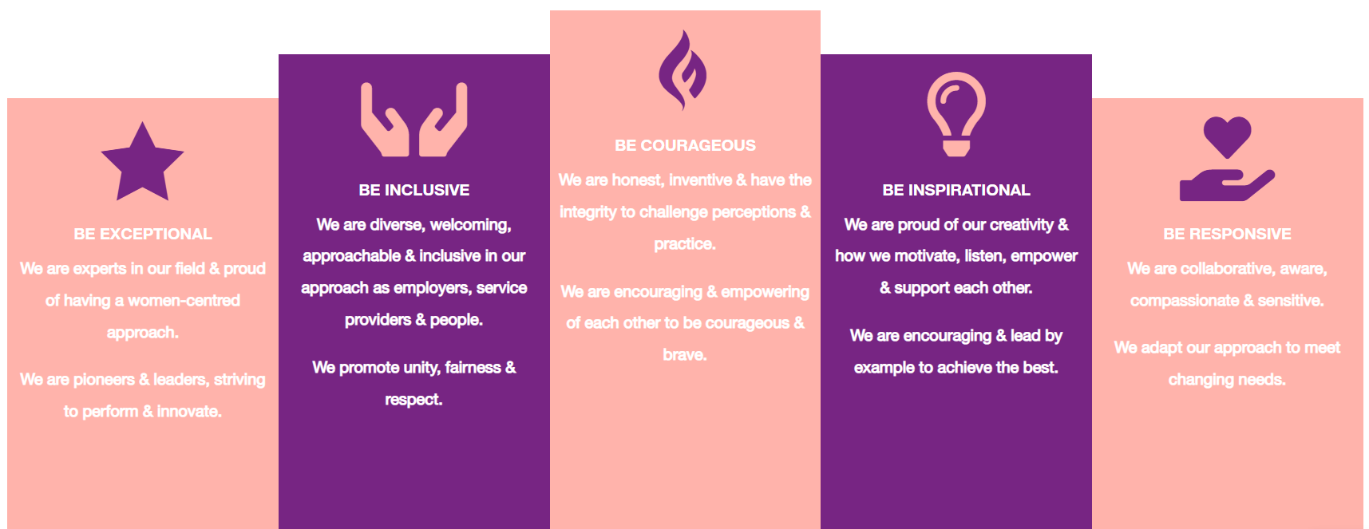

1. Be Exceptional
• We are experts in our field & proud of having a women-centred approach
• We are pioneers & leaders, striving to perform & innovate

2. Be Courageous
• We are honest, inventive & have the integrity to challenge perceptions & practice
• We are encouraging & empowering of each other to be courageous & brave

3. Be Inclusive
• We are diverse, welcoming, approachable & inclusive in as employers, service providers & people
• We promote unity, fairness & respect

4. Be Inspirational
• We are proud of our creativity & how we motivate, listen, empower & support each other
• We are encouraging & lead by example to achieve the best

5. Be Responsive
• We are collaborative, aware, compassionate & sensitive
• We adapt our approach to meet changing needs

