
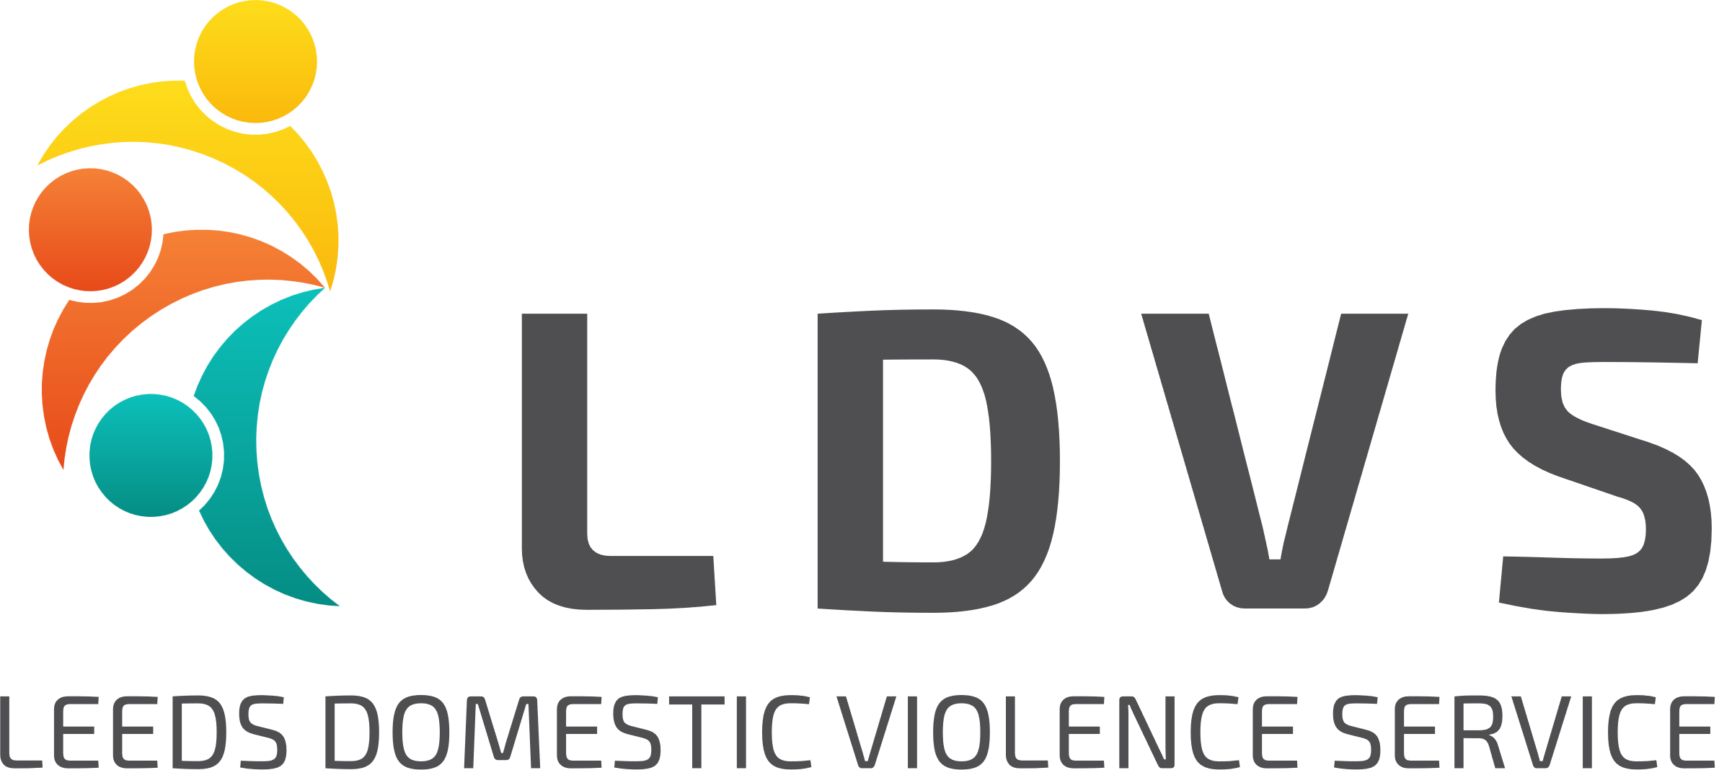

Sanctuary Support Worker – LGBTQIA+ Specialist
Fixed term until March 2026 (with the potential to extend subject to funding)
£28,228 FTE (pro rata)
21 hours per week*
*We welcome applications from those looking for part-time and full-time hours as we may be able to offer additional hours in a very similar role within the wider LDVS provision.
The Sanctuary Support Team is looking for a compassionate and skilled Sanctuary Support worker to join their dedicated team. This role is all about providing life-changing one-to-one support for individuals and families who need ‘sanctuary’ to keep them safe from domestic abuse.
​
This post is held at Behind Closed Doors, one of the partner organisations involved in the Sanctuary Support Team – a city-wide consortium led by Leeds Women’s Aid and employed by Leeds Domestic Violence Service partner organisations, dedicated to helping individuals stay safe in their homes. Other organisations established in the team are Women’s Health Matters, Karma Nirvana, Shantona, PAFRAS, and Asha Neighbourhood Project, all with a different specialism, working closely together to deliver support and safer housing for individuals and families recovering from domestic abuse.
​
The LGBTQIA+ specialist, based at Behind Closed Doors, will be working with victim-survivors from the LGBTQIA+ community, ensuring they receive tailored one-to-one support to rebuild their lives safely.

There is an essential requirement under the Sexual Orientation Regulations 2003 that the post holder has experience of LGBT+ needs and the impact of discrimination. Candidates should demonstrate a thorough understanding of LGBT+ people’s lives, including awareness of the issues that LGBT+ survivors might face.

For more detailed information about this post, how to apply and to download the application pack please go to the Behind Closed Doors or Leeds Women’s Aid website:
https://behind-closed-doors.org.uk/about-us/job-vacancies/
https://behind-closed-doors.org.uk/about-us/job-vacancies/
https://leedswomensaid.co.uk/jobs/
Closing date for applications: 2nd May 2025
Interviews to be held: 12th May 2025
For an informal conversation about these posts please contact the Sanctuary Support Team Leader – Lucy Smithson at LucyS@ldvs.uk
LDVS is fully committed to the principles of equality of opportunity and applications are welcome from all sections of the community. LDVS and the wider Sanctuary Support Team is made up of diverse and inclusive organisations. We would particularly welcome applications from members of the LGBTQIA+ community and Black, Asian or Minoritized Ethnic communities.

